Personal Project Portfolio

Software Design and Development

Edward Webb

# Proposal

This program will take several variables relating to projectile motion eg. Initial velocity, maximum height the projectile reaches, the range of the projectile, etc. and will determine the rest of the variables and show the path of the projectile on a graph. Developing the graph will involve measuring what height the projectile is at a point of the projectile’s motion and placing a dot on the graph. The graph could have multiple dots to create a curve.

Advantages: Small project, is possible in Visual Basic 6

Disadvantages: Possibly too hard to do in Visual Basic 6 in creating the graph, and will require many functions to determine the rest of the variables.

# Define the Problem

## Identification of the Problem

The problem presented is that physics students require a program that can easily solve and visualise projectile motion problems. This would include calculating the initial velocity, its maximum height, its range, its horizontal and vertical velocity at any point of time, and its time. It must be able to input different variables and output the rest of the variables. A graph which visualises the projectile’s motion is also required to allow physics students to easily solve any projectile motion problem.

## Ideas

* The program could calculate the position of the ball at a certain point in its motion and pinpoint it on the graph. After creating many points, these points can be connected, creating a curve.
* Several variables will be listed with a box allowing the user to input a number into it
* If there is not sufficient information, a prompt can appear after the user enters the information saying that there is not sufficient information.
* After some information has been inputted by the user, the rest of the boxes can be filled by calculating from the user’s information and the graph can be shown.

## Requirements

1. The program is to run on Microsoft Windows machines and must fit a 1920x1080 resolution as this is the resolution that school computer displays have.
2. The program must not crash when the program is put in use
3. The program must run on a computer with 4GB RAM.
4. The program must be able to visualize the projectile motion specified by the user and output variables that can be calculated from the information inputted into the program.
5. If the program cannot calculate any information from the data given, the program will output an error displaying that the information given is not sufficient.
6. The user should be able to use the program again after the user has inputted information for a projectile motion problem without having to reopen the program.

## Gantt Chart

# Understanding the Problem

### Storyboard

## Context Diagram

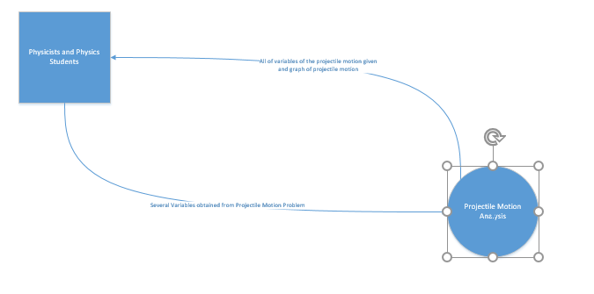

## Feasibility Study

This project is designed for physicists and physics students, and its purpose is to solve projectile motion problems. Many physics students and physicists have to solve projectile motion problems, and this program can help visualise and aid with solving these problems.

The boundaries of this project include not being able to pinpoint a specific point of the projectile’s motion on the graph, as Visual Basic 6 does not have the capability to create this. The graph will also not be a smooth curve, as Visual Basic 6 does not have a proper graphing feature. However, dots can be created on the graph to attempt to create a curve.

The benefits of creating this project include being able to solve projectile motions much more easily, and allowing physics students to check their answers easily if they need to. The program can also provide more accurate answers for projectile motion problems than what physicists can calculate by hand, and can create a visual aid for students by showing what the projectile motion should look like on a graph.

This project is possible in Visual Basic 6 as points can be placed on a drawn graph to create a curve on the graph, which visualises the projectile’s motion. There is also a limited amount of possibilities for projectile problems, and so all projectile motion problems can be solved using a program. Although Visual Basic 6 does not have a graphing function, it is still possible using drawing functions to create a graph.

One person is needed to actually create and maintain the program, and it will most likely take around 1-2 months to create. Visual Basic 6 must be used to create the program as the programmer who will develop it can program efficiently in Visual Basic 6. A computer with Windows is needed as Visual Basic 6 can only run on Windows.

If the project is not completed, the graph can be left out to allow most of the functionality of the program to operate. As the graph is the most complex part of the program and only helps achieve the purpose of the program, it can be left out if it has to. This will allow students to still easily use the program, and the project to be completed in less time.

## Social and Ethical Issues

### Malware

Malware has been considered as a possible issue for the software, and so the software after completion will be scanned by antivirus software and uploaded to virustotal.com, a Google-developed website that uses many antivirus software to ensure that the software is free of malware and viruses.

### Intellectual Property

The program is owned by the Department of Education and Communities of New South Wales, as it is developed due to educational purposes. Therefore, the program’s intellectual property is protected by copyright laws as no license has been given to it.

### Quality

The program will be developed to the highest quality possible in the time frame provided. The program will be tested with school computers to ensure that it meets hardware requirements, which are that it must run on Windows with a 1920x1080 resolution. Error checking will be built into the code, and all errors that are found during the development process will be fixed and solved.

### Issues

After development, users who use the program may report any bugs and issues with the developer, and they will be fixed.

### Ergonomics

User interface elements will be used to ensure consistency with other software, which makes the program easy to use. As the program is targeted towards physicists and physics students, the program will be developed with the demographics of this target market in mind to ensure that the target market find the program easy to use. Industry standards will be used to do this. The program will also be tested by physics students to make sure the software meets the needs of physics students and physicists.

### Inclusivity

The graph in the program will follow normal science standards, with the dependent variable on the y axis and the independent variable on the x axis. All units used for variables entered and outputted will follow SI units as well to give physics students units they expect. The program will have no cost, therefore economic issues will not be considered. No offensive language will be used in the program, and a variety of testers will be used including people from both genders to address the possible inclusivity issue of gender. To address disability issues, shortcuts like TAB and ENTER can be used to operate the program as well.

### Privacy

To address a possible privacy issue, no information will be kept in a database, and the program will not save any information entered by the user.

# Plan and Design

## Data Flow Diagram

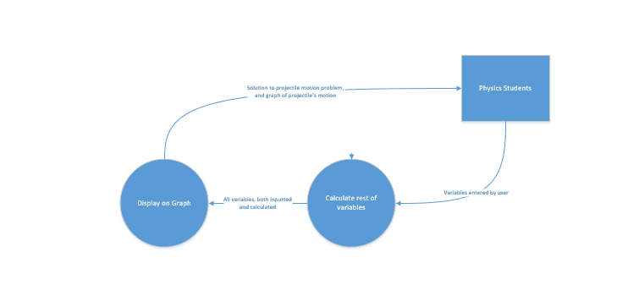

## Specifications

* Windows XP or later
* 1GB RAM or more
* 1920X1080 resolution
* Any processor will run it

## Test Data

## Documentation (technical manual)